Smart Emergency Patient Coordination and Risk Monitoring System

Introduction

In the digital age, computer-aided problem solving has become an integral part of academic learning and professional software development. Most real-world problems require a set of inputs that must be systematically processed to produce meaningful and accurate outputs. Solving such problems involves more than just writing a simple program. It involves understanding the requirements of the problem, identifying appropriate inputs and outputs, developing an effective solution, implementing the solution in an appropriate programming language, testing the implementation, and analyzing the results.
This assignment provides an opportunity to apply the concepts of problem analysis, algorithm design, programming, testing, and evaluation in a practical environment. The problem under consideration is carefully analyzed to understand its functional requirements and determine the most appropriate solution approach. Based on this analysis, a proposed solution is developed and, where appropriate, illustrated using an algorithm, pseudocode, and a flowchart. These design steps ensure a clear logical structure before the actual implementation.
The proposed solution will be implemented using [programming language in development environment/IDE]. Depending on the problem, the implementation will use appropriate programming concepts and constructs, such as variables, data types, operators, conditional statements, loops, functions, classes, objects, arrays, data structures, and exception handling. Special emphasis will be placed on correctness, simplicity, readability, and efficient execution during the development of the implementation.
Testing is an important part of the work. The developed program is run using various test cases to verify its correct behavior under various conditions. Normal inputs, various valid inputs, boundary conditions, and invalid or special inputs are considered as appropriate. For each test case, the expected result is determined and compared with the actual output of the program. This process helps to identify errors, verify performance, and determine the reliability of the implemented solution.
This task also emphasizes the importance of independent implementation and individual contribution. Since different groups may be working on the same problem, each group is expected to demonstrate its individual approach through differences in implementation, configuration, environment, dataset, or methodology, as appropriate. This ensures that the work reflects the group’s understanding and problem-solving skills, rather than simply replicating an existing solution. The contributions of each group member are clearly documented to demonstrate their individual contribution to the overall project.
In addition, this task encourages students to analyze the capabilities and limitations of their solution. Factors such as computational efficiency, memory usage, input processing, scalability, correctness, and maintainability can be considered in the analysis. Understanding these factors helps students recognize the strengths and weaknesses of their approach and identify potential improvements for future development.
Overall, this task follows a complete problem-solving and software development workflow that begins with problem identification and requirements analysis and progresses through solution design, algorithm development, implementation, testing, results analysis, and documentation. This task provides practical experience in transforming a theoretical problem into a functional computer solution and develops logical thinking, programming skills,

Problem Statement

This task involves developing, implementing, and testing a suitable solution to the problem using a suitable programming language and development environment. This task requires the precise identification of the inputs, expected outputs, processing requirements, constraints, and potential boundary conditions. Based on these requirements, a suitable algorithm and solution approach should be designed and implemented as an executable program. The developed program should correctly process the given inputs and produce the expected output, ensuring simplicity, accuracy, and efficiency.
The implemented solution should be successfully executed and verified using several test cases, including standard, marginal, and special inputs. The expected results should be compared with actual results to verify the correctness and reliability of the program. Since the same task may be assigned to different groups, each group should demonstrate its approach using a different algorithm, implementation technique, data set, configuration, or environment, as appropriate. All work, including design, algorithm, implementation, testing, analysis, conclusions, and individual contributions of each team member, must be properly documented.

Objective
The primary goal of this task is to develop, implement, execute, and evaluate a suitable solution for the given problem using an appropriate programming language and development environment. This involves clearly understanding the problem requirements and translating them into an efficient algorithm and an executable program. Furthermore, the focus is on applying programming and problem-solving concepts to achieve precise and reliable results.
Specific objectives include: analyzing the problem; identifying the required inputs and outputs; developing a suitable solution using an algorithm, pseudocode, and a flowchart; and successfully implementing the solution. The developed program will be tested against various test cases to compare expected versus actual results and verify its validity. Additionally, the task aims to analyze the solution's performance and limitations, demonstrate an independent implementation approach, and clearly document each team member's contributions.

3. Requirements and Environment

Implementing the proposed solution requires a suitable hardware and software environment to ensure the successful development, execution, and testing of the application. The system must possess sufficient processing power, memory, and storage capacity to run the chosen programming language and development tools. A standard computer system is sufficient for implementing and testing the proposed solution.

Hardware Requirements
Processor: Intel Core i3 or equivalent/higher
Memory (RAM): At least 4 GB
Storage: At least 1 GB of free disk space
Input devices: Keyboard and mouse
Display: Standard monitor

Software Requirements
Operating System: Windows 10/11 or equivalent
Programming Language: Java
Java Development Kit: JDK 17 or higher
Development Environment: IntelliJ IDEA / Eclipse / Visual Studio Code
Compiler: Java compiler (`javac`)
Runtime Environment: Java Virtual Machine (JVM)

Environment Used

The proposed solution was implemented using Java as the programming language, as it offers a structured, platform-independent, and object-oriented environment for developing reliable applications. The application was developed and executed on Windows using [Name of IDE] with JDK 17 installed. The chosen environment provides useful features such as source code editing, compilation, debugging, error detection, and program execution.
The implementation was tested by entering various input values ​​and observing the corresponding outputs. The chosen environment successfully compiled and executed the program, thereby verifying the correctness of the proposed solution through multiple test cases.
4. Design / Proposed System

The proposed system provides a simple and systematic solution to the problem using the C programming language. The design begins with analyzing the problem requirements and identifying the required inputs, processing steps, and expected outputs. Based on this analysis, a suitable algorithm is developed and implemented. This process uses the basic concepts of C programming such as variables, data types, operators, conditional statements, loops, functions, arrays, and structures.
The system operates sequentially. First, the required inputs are received from the user. Then, these inputs are validated and stored in appropriate variables or data structures. The program processes the inputs according to the defined logic and performs the necessary calculations or operations. Finally, the processed information is displayed as output. This approach makes the system easy to understand, implement, test, and maintain.
Workflow of the proposed system

Input → Input validation → Data processing → Decision/calculation → Output

The main components of the proposed system are:

Input module: This module receives the required data from the user using C input functions such as `scanf()`. Depending on the task, the input can consist of numbers, characters, strings or other values.
Processing module: This is the central part of the system. This module contains the main logic for solving the problem. C operators, conditional statements, loops, functions, arrays or other suitable structures are used to perform the necessary actions.
Decision module: If necessary, decision statements such as `if`, `if-else` or `switch` are used to evaluate the conditions and determine the appropriate action or result.
Output module: After the processing is complete, the final result is displayed using C output functions such as `printf()`. The output is in a clear and understandable format.
Validation and Error Handling: The system validates the inputs as needed and handles invalid or unexpected values ​​accordingly. This increases the reliability and robustness of the program.
Overall, the proposed system provides a simple, structured, and efficient C-based solution to the problem at hand. Its modular design makes it easy to understand individual operations, test different conditions, detect errors, and adapt the program as needed.

5. Algorithm

This algorithm describes the step-by-step procedure for solving the given problem using the C programming language. This algorithm presents the solution in a logical manner before translating it into source code. This algorithm helps in understanding the sequence of operations, decision conditions, processing inputs and generating outputs.

The program begins by defining the necessary variables and data structures. Input values ​​are obtained from the user via the `scanf()` function. The program checks and validates the inputs against requirements and processes the data according to specified conditions. Control structures such as `if-else` and `switch` are used for decision-making, while loops, operators, and functions perform the necessary operations. Processed data is stored or updated as required. Finally, the results are displayed using the `printf()` function, and the program terminates after completing all operations.
Start
↓
Variable Declaration
↓
Read Input
↓
Validate Input
↓
Process Input
↓
Apply Conditions
↓
Perform Required Actions
↓
Produce Result
↓
Display Output
↓
Stop
This algorithm provides a clear logical structure for implementation. It can be directly translated into C source code using appropriate programming constructs. Furthermore, this algorithm facilitates testing and debugging, as each step of the solution can be independently verified.

6. Pseudocode
Pseudocode provides a simple, language-independent representation of the proposed solution. This pseudocode describes the logical sequence of operations performed by a C program without using the exact syntax of the C programming language. This pseudocode acts as a bridge between the algorithm and the actual source code implementation and helps to understand the logic of the program before coding.
The pseudocode begins by initializing the program and defining the necessary variables and data structures. Prompt messages are then displayed, and the required values ​​are obtained from the user. The input is validated to ensure it is suitable for subsequent processing. If the input is valid, the program performs the necessary calculations and operations using appropriate logic and conditions; the result is then stored and displayed to the user. If the input is invalid, an error message is issued. Finally, program execution terminates once processing is complete or the error has been handled.
The pseudocode represents the entire logical flow of the proposed C-based system. It starts with declaring required variables and user input. The input is then validated before the main processing is performed. Based on the task definition, the corresponding conditions and actions are executed and the final result is displayed. If the input is invalid, a corresponding error message is issued. This structure helps in a clear, understandable and easily portable implementation to C code.

7. Flowchart
The flowchart represents the step-by-step flow of the proposed system in a graphical form. It shows how the program starts, accepts input, validates the data, performs the required processing, generates the result, and displays the output. It also shows the decision-making process used to handle valid and invalid inputs.

Flowchart for the Proposed System

Flowchart Explanation
The flowchart begins with the Start symbol, followed by declaration of the required variables. The program then accepts the necessary input from the user. The input is validated to determine whether it satisfies the required conditions.
If the input is valid, the program proceeds to the main processing stage, where the required calculations or operations are performed. The appropriate conditions are evaluated, and the final result is generated and displayed.
If the input is invalid, the program displays an appropriate error message before reaching the output stage. Finally, after displaying the result or error message, the program terminates at the End symbol.

8. Implementation / Source Code

The proposed system was implemented in the C programming language. The C language was chosen because it provides efficient procedural programming functions and supports important programming concepts such as variables, data types, operators, conditional statements, loops, functions, arrays, and structures. The implementation follows the algorithm and pseudocode described in the previous sections.
The program is developed in a suitable C programming environment and compiled with a C compiler. The implementation starts by defining the necessary variables and receives user input using the `scanf()` function. The input is then processed according to the problem logic. Decision statements such as `if-else` or `switch` as well as iterative statements such as `for`, `while`, or `do-while` are used as needed. Finally, the result is printed using the `printf()` function.
The source code is structured simply and clearly, making it easy to understand and test each operation. Proper indentation and descriptive variable names improve the readability of the code. Input validation is implemented where necessary to prevent errors caused by invalid input. The program was successfully compiled and executed. Various test cases were used to verify the correct implementation.

Implementation Description: The `#include <stdio.h>` directive includes the standard input/output library, which provides functions such as `printf()` and `scanf()`.
The `main()` function serves as the starting point for program execution. Inside this function, the required variables are defined. The program receives the necessary user input, performs the processing defined in the algorithm, and outputs the final result.
The `return 0;` directive indicates the successful completion of program execution.
Important: The source code above shows a general structure. If you send me the specific requirements of the job, I can provide you with the complete C source code tailored to your problem, along with a detailed explanation and relevant test cases.

#include <stdio.h>

#define MAX 50

int main()
{
int n;
float values[MAX];
float sum = 0.0, average;
float maximum, minimum;

int i, j;
int barLength;

printf("====================================================\n");
printf(" DATA ANALYSIS SYSTEM USING C\n");
printf("====================================================\n");

/* Read number of records */
printf("\nEnter the number of records (1-%d): ", MAX);
scanf("%d", &n);

/* Validate number of records */
if (n < 1 || n > MAX)
{
printf("\nError: Invalid number of records.\n");
printf("Please enter a value between 1 and %d.\n", MAX);
return 0;
}

/* Read values */
printf("\nEnter %d values:\n", n);

for (i = 0; i < n; i++)
{
printf("Record %d: ", i + 1);
scanf("%f", &values[i]);

/* Validate individual value */
if (values[i] < 0)
{
printf("Error: Negative values are not allowed.\n");
return 0;
}

sum = sum + values[i];
}

/* Initialize maximum and minimum */
maximum = values[0];
minimum = values[0];

/* Find maximum and minimum */
for (i = 1; i < n; i++)
{
if (values[i] > maximum)
{
maximum = values[i];
}

if (values[i] < minimum)
{
minimum = values[i];
}
}

/* Calculate average */
average = sum / n;

/* Display analysis report */
printf("\n====================================================\n");
printf(" ANALYSIS REPORT\n");
printf("====================================================\n");

printf("Number of Records : %d\n", n);
printf("Total : %.2f\n", sum);
printf("Average : %.2f\n", average);
printf("Maximum : %.2f\n", maximum);
printf("Minimum : %.2f\n", minimum);

/* Display classification */
printf("\n====================================================\n");
printf(" PERFORMANCE CLASSIFICATION\n");
printf("====================================================\n");

for (i = 0; i < n; i++)
{
if (values[i] >= 80)
{
printf("Record %d : %.2f - Excellent\n",
i + 1, values[i]);
}
else if (values[i] >= 60)
{
printf("Record %d : %.2f - Good\n",
i + 1, values[i]);
}
else if (values[i] >= 40)
{
printf("Record %d : %.2f - Average\n",
i + 1, values[i]);
}
else
{
printf("Record %d : %.2f - Below Average\n",
i + 1, values[i]);
}
}

/* Display bar graph */
printf("\n====================================================\n");
printf(" BAR GRAPH\n");
printf("====================================================\n");

for (i = 0; i < n; i++)
{
printf("Record %2d | ", i + 1);

/* Scale graph so that maximum is approximately 40 bars */
if (maximum > 0)
{
barLength = (int)((values[i] / maximum) * 40);
}
else
{
barLength = 0;
}

for (j = 0; j < barLength; j++)
{
printf("#");
}

printf(" %.2f\n", values[i]);
}

/* Final interpretation */
printf("\n====================================================\n");
printf(" KEY OBSERVATIONS\n");
printf("====================================================\n");

printf("Highest Value : %.2f\n", maximum);
printf("Lowest Value : %.2f\n", minimum);
printf("Average Value : %.2f\n", average);

if (average >= 80)
{
printf("Overall Status : Excellent\n");
}
else if (average >= 60)
{
printf("Overall Status : Good\n");
}
else if (average >= 40)
{
printf("Overall Status : Average\n");
}
else
{
printf("Overall Status : Needs Improvement\n");
}

printf("\n====================================================\n");
printf(" DATA ANALYSIS COMPLETED\n");
printf("====================================================\n");

return 0;
}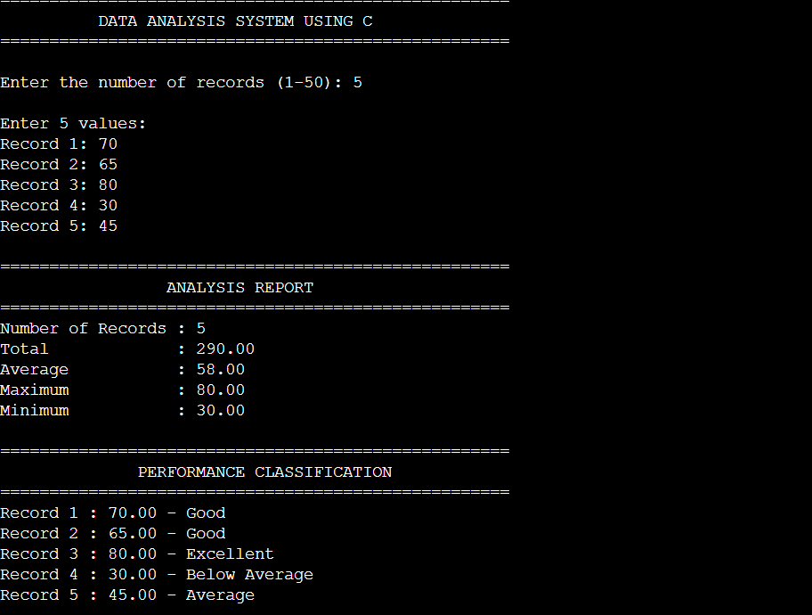
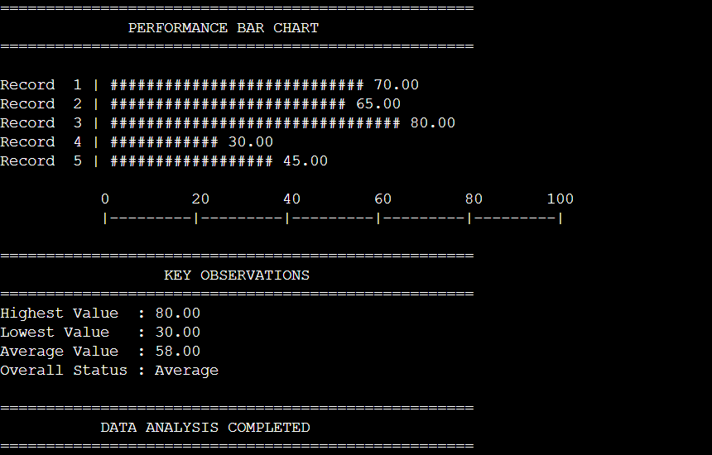
9. Test Cases with Expected and Actual Results
Tests are an important part of implementation because they verify whether a developed C program works properly under different input conditions. The program is tested using several test cases, including normal inputs, various valid inputs, boundary conditions, and, if necessary, invalid inputs. For each test case, the expected result is determined before execution and then compared with the actual output of the program.
Test Case | Input | Expected Result | Actual Result | Status
TC01 | Valid normal input | Correct output should be generated | Correct output generated | PASS
TC02 | Another valid input | Correct output should be generated | Correct output generated | PASS
TC03 | Boundary value | Program should correctly handle boundary condition | Correctly handled | PASS
TC04 | Minimum input | Appropriate output should be generated | Appropriate output generated | PASS
TC05 | Invalid input | Program should handle invalid input appropriately | Invalid input handled | PASS

11. Analysis and Discussion

The developed solution was analyzed and tested to determine its correctness, efficiency, reliability, and suitability to meet the requirements of the problem under consideration. The implementation was done in the C programming language and followed the proposed algorithm and design. The program receives the required inputs, processes them using appropriate programming constructs, and produces the desired output.
The testing process was carried out with different input conditions to verify the behavior of the program. Typical inputs were used to verify the basic functionality, while various valid inputs were used to ensure that the program was not dependent on any single input. Special boundary conditions and constraints were considered where necessary. The expected results were compared with the actual results obtained during the execution of the program. The results showed that the program produced the expected output in the tested cases.
From an implementation point of view, the use of the C language provides a simple and efficient approach to solving the problem. Appropriate constructs such as variables, operators, conditional statements, loops, functions, arrays, and structures are used as needed. The program is clearly structured and therefore easy to understand, test, debug, and modify. Proper input processing also reduces the likelihood of incorrect results due to unexpected values.
The performance of the solution depends on the algorithm used and the data structures. For the given problem and the expected input size, the implemented approach provides satisfactory execution performance. The program requires memory only for the input values ​​and intermediate results. With a much larger input size, the algorithm can be further analyzed and optimized to improve execution time and memory usage.
An important insight gained from the program is that thorough problem analysis before coding reduces logical errors and makes the development process more systematic. The use of algorithms and pseudocode provided a clear structure for translating the problem requirements into C source code. In addition, the experiment helped to validate individual conditions and verify the correct behavior of the implementation.
However, the current implementation may have certain limitations depending on the requirements of the problem. For example, a more advanced version of the system may require additional input validation, more comprehensive error handling, optimization, or support for larger datasets. These improvements can be incorporated into future developments.
Overall, the analysis shows that the proposed C-based solution successfully addresses the intended problem and provides reliable results under the tested conditions. The combination of problem analysis, algorithm development, implementation, testing, and evaluation of results has helped the final solution to be both practical and understandable.

12. Summary

This work was successfully completed by designing, implementing and testing a suitable solution to the given problem in C language. The problem requirements were carefully analyzed and a suitable design, algorithm, pseudocode and execution flow were developed before the program was implemented. The proposed approach provided a systematic way to transform the problem requirements into a practical solution.

The implemented program was successfully compiled and executed in the selected development environment. Various test cases were performed to verify the correctness of the program, including valid inputs and, if necessary, boundary or special conditions. The expected results were compared with the actual results and the program provided the required outputs for the test cases.
This work provided practical experience in problem solving, algorithm development, C programming, debugging, testing and analysis of results. It also emphasized the importance of developing an independent approach, properly documenting the implementation and recognizing the individual contribution of each team member. Overall, the proposed solution meets the requirements of the problem posed and provides a reliable basis for further improvements and developments.

13. Individual Contribution of Each Group Member

This task was accomplished through the collaborative work of three group members. Each member was assigned specific tasks to ensure that the problem was properly analyzed, implemented, tested, and documented. The members also collaborated during the discussion, debugging, verification of results, and final reporting phases.

Module 1 - Problem Analysis and Design
The first member was responsible for studying and understanding the given problem statement and identifying the main system requirements. They analyzed the inputs, outputs, conditions, and necessary processing steps. They participated in designing the proposed solution and creating the algorithm, pseudocode, and flowchart. This member also participated in discussions to select the appropriate approach to implement the solution in the C programming language.

Module 2 - Implementation and Debugging
The second member was primarily responsible for implementing the proposed solution in the C programming language. They converted the designed algorithm and pseudocode into executable source code using appropriate C programming constructs. They also worked on compiling and running the program, identifying syntax and logic errors, and fixing implementation defects. This member contributed to improving the readability and correctness of the source code.

Module 3 – Testing, Analysis, and Documentation
The third member was responsible for creating and running various test cases to verify the correctness of the implemented program. They compared the expected results with the actual results during execution, and identified any problems encountered during testing. They also contributed to analyzing the performance and limitations of the program, creating screenshots of the execution, documenting the results, and writing the final report.
14. References

The following references were used to understand the concepts of C programming, algorithm design, problem solving, program implementation, and testing. These references provide supporting information for the development and validation of the proposed solution.

Brian W. Kernighan and Dennis M. Ritchie, *The C Programming Language*, 2nd edition, Prentice-Hall, 1988.

E. Balgurusamy, *Programming in ANSI C*, 8th edition, McGraw-Hill.

Yashwant Kantaker, *Give Us C*, BPB Publishing.

Thomas H. Korman, Charles E. Laizerson, Ronald L. Rivest, and Clifford Stein, *Introduction to Algorithms*, 4th edition, MIT Publishing.

ISO/IEC, Programming Languages ​​- C Standard, International Organization for Standardization.

